|  |  |
| --- | --- |
| Point | **Significance** |
| 1 | 0 cm (for measurement calibration) |
| 2 | 1 cm (for measurement calibration) |
| 3 | 2 cm (for measurement calibration) |
| 4 | Upper anterior corner of rectangle circumscribing the calcaneus |
| 5 | Upper posterior corner of rectangle circumscribing the calcaneus |
| 6 | Lower posterior corner of rectangle circumscribing the calcaneus |
| 7 | Lower anterior corner of rectangle circumscribing the calcaneus |
| 8 | Superior anterior point of the anterior process |
| 9 | Apex of the Gissane angle |
| 10 | Summit of the posterior facet |
| 11 | Most posterior point of the calcaneal tuberosity |
| 12 | Insertion of the plantar fascia |
| 13 | Inferior anterior point of the anterior process |
| 14 | Summit of the calcaneal tuberosity |
| 15-35 | Arising slope leading to the summit of the calcaneal tuberosity |
| 36 | Inferior point of the retrocalcaneal tendon-bone contact surface/superior starting point of the Achilles insertion |
| 37-89 | The whole tendon-bone insertion of the Achilles on the calcaneal tuberosity |
| 90 | Weightbearing point |

**Table 1: Anatomical landmarks of the calcaneus, and the calcaneal tuberosity.** 90 points corresponding to various anatomical landmarks were placed on each calcaneus of the 40 control feet and plotted to develop a standard circle algorithm, so it can be used to map out the individual standard morphology of any calcaneus with or without IAT on the lateral weightbearing XR view through this rectangle circumscription method.

**Figure 1. Calcaneal Tuberosity Mapping.** Each calcaneus was circumscribed within a rectangle and points 4 to 90 was plotted with some of them representing standardized anatomical markers, while the rest being evenly distributed between two anatomical markers to map the contour of the bone. (Table 1) Of note, points1-3 were measurement calibration markers and therefore not depicted here.

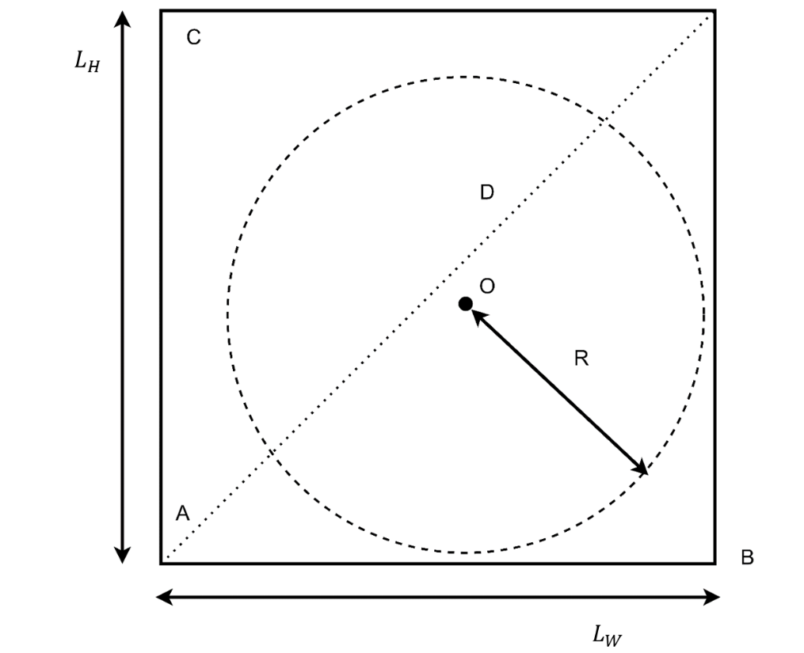

**Figure 2. Schematic denotations for the circle fitting algorithm.** The fitting algorithm utilizes a circular function with center O and radius R. The rectangular box circumscribes the calcaneus in each of the control feet and is denoted by width , height , diagonal length D, and corners A, B, and C.

**Figure 3. Fitted Standard Circle.** The standard circle was statistically fitted using 40 control feet in relation to the height and width of the calcanei. Green dots are the preliminarily established anatomical markers that are associated with anatomical landmarks previously described in Table 1. Blue dots denote the superior parts of the calcanei outlined while the red dots represent the Achilles insertion site. All dots are labelled using numbers that correspond to landmarks denoted in Table 1. X and Y axis of the figure are normalized by calcaneus height and width.



**Figure 4 The Concept of PAIA.** PAIA was developed to both reflectthe degree of enlargement of the calcaneal tuberosity in feet with IAT and represent the angle by which the enlarged calcaneal tuberosity curve can be rotated around the weightbearing point to best fit the ideal contour (Standard Circle) of the calcaneus. In Figure 4A, purple dots denote the superior section of the calcaneus, the red dots outline the enlarged calcaneal tuberosity, while green dots represent the realigned calcaneal tuberosity to best fit the Standard Circle of the calcaneus with IAT. Figure 4B visualized the change of the rotational loss while rotating the enlarged calcaneus tuberosity to its ideal contour predicted by the Standard Circle. PAIA was determined at the insertion angle associated with the local minima of the rotation loss. Based on this angle, the individualized design of the Zadek Osteotomy was produced as illustrated in figure 4C, an illustration of the physical rotation and realignment of the enlarged calcaneus tuberosity.

|  |  |  |
| --- | --- | --- |
|  |  |  |
| 0.41 ± 0.08 | 0.45 ± 0.03 | 0.42 ± 0.05 |

**Table 2 parameters of the Standard Circle derived from the 40 control feet without IAT**

**Figure 5 Simulated anterior shift of the apex of the Zadek Osteotomy.** When the weightbearing point was used as the apex of the Zadek Osteotomy, the length of the calcaneus was shortened, and the lever length of the Achilles tendon was changed (Figure 5A) after the osteotomy was closed. When the apex of the Zadek Osteotomy was shifted anteriorly, in addition to the above mentioned changes in the length of the calcaneus and the lever length of the Achilles tendon, the calcaneal pitch angle is reduced as well (Figure 5B).